**Project 1**

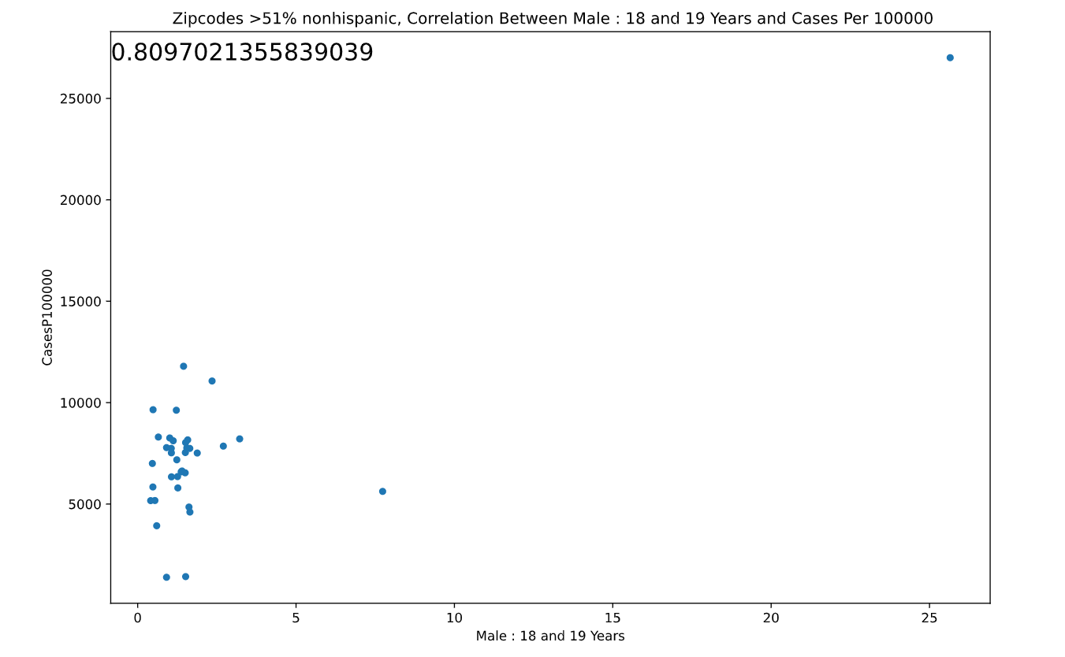

Non-Hispanic Males 18-19:

Non-Hispanic males shows the greatest correlation amongst the other age groups, and vs Hispanic males. Majority of this group made up 0% to 4% of the zip code’s population. The more there are 18- to 19-year-old Non-Hispanics, the more covid cases you’ll see. The males 18 to 19 age group were 2nd place in all males to contract covid.

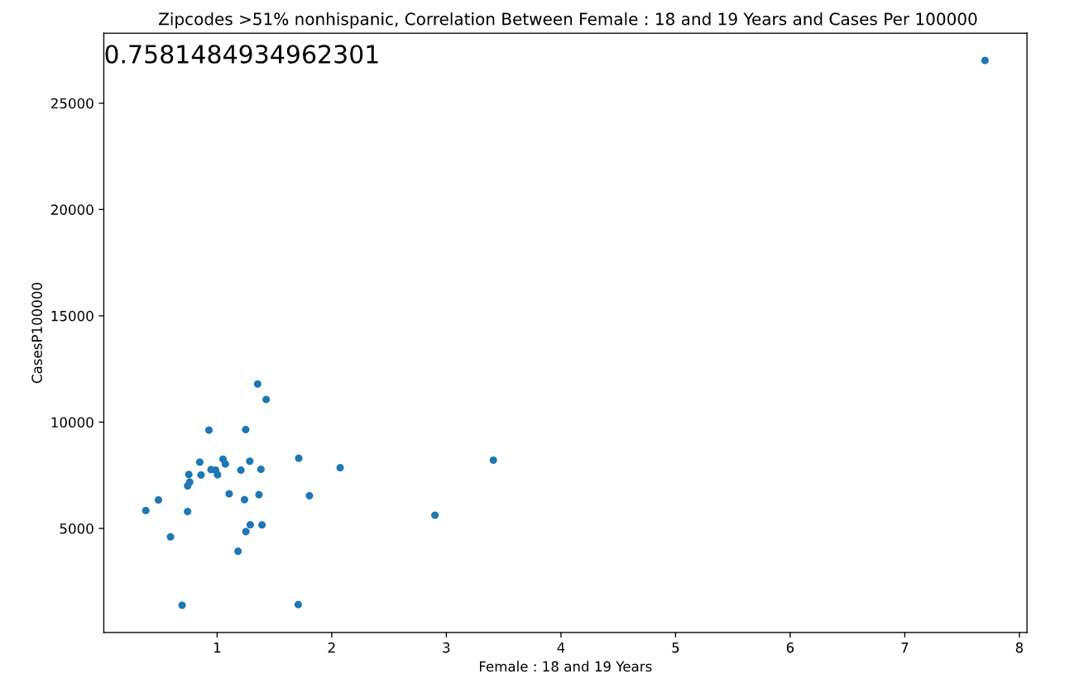

Non-Hispanic Females 18-19:

Non-Hispanic females had one of the highest correlation values compared to other age groups. Females in this age group also came from higher income households.

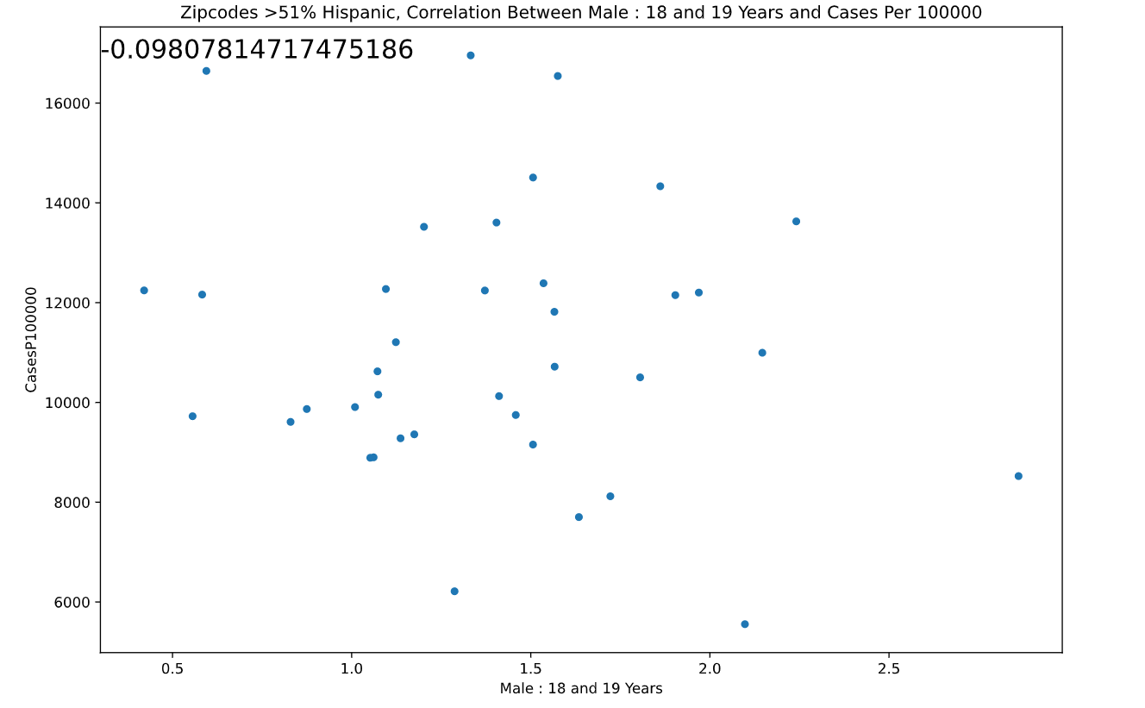

Hispanic Males 18-19:

Hispanic males had no correlation. Lower end value of correlation from the entire dataset that we reviewed. Polar opposite to Non-Hispanics of the same age group. Making up less than 3% of the zip code’s population.

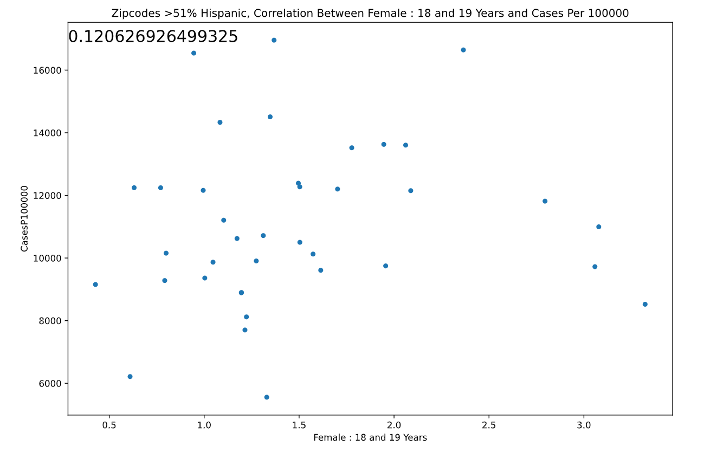

Hispanic Females 18-19:

Hispanic females also had no correlation. Just like males of the same age group the correlation was on the lower end of the spectrum of data. Non-Hispanic females of the same age group also were pretty opposite as well.